1. Use unset array.

Input:

<?php

    $emp= array("Priyanka", "Ram", "Manisha", "Payal");

    echo "Employee Names<br>";

    print_r($emp);

    echo "<br>";

    unset($emp[1]);

    echo "Modified arrays:<br>";

    print_r($emp);

?>

Output:

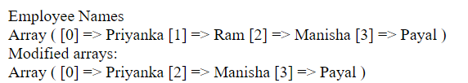

1. Write a PHP script to find size of array.

With **count()** function.

Input:

<?php

$salary= array(21632, 13515, 54652, 23155);

     $size=count($salary);

     echo "The size of array is: $size.";

?>

Output:



With **sizeof()** function.

Input:

<?php

$salary= array(21632, 13515, 54652, 23155);

     $a=sizeof($salary);

     echo "The size of array is : $a";

?>

Output:

